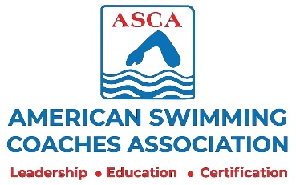

2020 ASCA Cyber World Clinic
FGC Coach Funded Registration Form
September 13-20 Hosted by the ASCA Global Village

Attendee(s) Name(s): 1.

2.

Attendee(s) Email(s): 1.

2.

Attendee(s) Phone: 1. 2.

Attendee(s) Address(es): 1.

2.

Team Name:

Clinic Fee: _____ X $30.00 (per coach) = TOTAL $

Credit Card Details: First Name:

Last Name:

Card Number:

Expiration Date:

- Or -

Send Check To: Dick Cavanah MUST be received by
951 U.S. Hwy #1 Sat.- August 22, 2020
North Palm Beach, FL 33408

Questions? - npbcoach4@aol.com

